Summary of OG-Core macroeconomic model
For linking OG-Core to the CLEWS model

This document is organized into the following sections

- Links to the model code and documentation online
- Summary of how the model works
- Summary of model inputs
- Summary of model outputs
- Types of research questions
- References to papers using OG-Core

1. Links to the model code and documentation online
All the code for OG-Core is available at https://github.com/PSLmodels/OG-Core.

The online documentation for the model, including description of the Python API as well as the theory behind the code, is available at https://pslmodels.github.io/OG-Core.

The model can also be directly downloaded from the Python Package Index (PyPI.org) as a Python package ogcore, which can be directly installed on your local machine using the pip install ogcore command.

2. Summary of how the model works
OG-Core is a large-scale open source dynamic general equilibrium model of country fiscal policy. This model solves for the equilibrium outcomes of an economy from the current period until a date in the distant future. The model first solves for the very long run economic outcomes, or steady-state. The model solves for the equilibrium transition path of the economic outcomes from the current period to a period in the distant future when the economy reaches its steady state.

In the most common calibration of OG-Core, equilibrium in each period is characterized by 1,120 nonlinear equations and unknown variables (2 household decisions x 80 ages x 7 ability types). Because we solve the model for up to 320 time periods (years), the equilibrium outcomes of the model are characterized by a system of more than 358,400 nonlinear equations.

These equations represent the optimal decisions of businesses and households over their lifetimes, subject to budget constraints and government activity. The model has very detailed demographic dynamics, modeling how the population distribution by age evolves over time using mortality rates, fertility rates, and immigration rates by age. OG-Core also accurately reflects the interactions of government with households (through taxes and transfers) and with businesses (through taxes and infrastructure investment). Finally, the model includes financial flows of capital from abroad.

3. Summary of OG-Core model inputs that could come from CLEWS outputs
A full list of the inputs to OG-Core is available in the online documentation in an appendix chapter entitled, “Model parameters”. These are the primary factors that the CLEWS model could inform and feed into.

- Carbon intensity by production sector to calibrate level of carbon tax (e.g. translate carbon price in $/t or a carbon cap into a tax that is dynamically adjusted for decarbonization of the economy over the time horizon)
- Energy, land and water footprint of policy scenarios (aligning
- Mix of factors to produce goods: e.g., mix of energy carriers in energy production, that can be used to update the input-output (IO) matrix in the OG model
  - Depends on level of detail in IO matrix
  - CLEWs can describe how gov't policy may change the mix of production like this -- and again this can be used to affect the IO matrix in OG
- Investment level and substitution of capital for other inputs
  - Expansion of clean energy infrastructure involves a transition to a more capital-intensive energy sector (i.e. capital is used to substitute for other inputs such as mining products e.g. gas, coal etc.).
  - It would further shift the balance of inputs to the energy sector away from mining products towards manufactured products (e.g. gas, coal to solar panels, wind turbines and batteries)
  - Shift in mining activities from fossil fuels to rare metals
  - In a CLEWs model a policy such as a carbon tax or a carbon cap would therefore spur investment in new green tech, but in OG, this increases cost of energy and would reduce investment
    - There are two main drivers pushing energy investment in opposite directions, reduced energy demand due to higher energy prices and internal restructuring towards more capital-intensive production. An open question would be how to align these different dynamics.
      - OG-core is better suited to assess the reduction in energy demand (and thus investment) due to relative price increase of energy relative to other factors of production
      - CLEWs is better suited to address the internal restructuring of the energy system towards a higher capital intensity.
    - Need to establish a way to and ensure that the economics of the joint representation work out in the way we expect (in line with data/experience)
    - Maybe we need to distinguish between different types of capital in the OG model (e.g., green and dirty capital)
      - Or is differentiated industries enough (e.g, green energy and dirty energy and the relative prices change)?

4. Summary of OG-Core model output that could inform CLEWS inputs
These outputs are the primary objects that could inform and feed into the CLEWS model. Formally, the output of the OG-Core model is summarized in the respective return objects (Python dictionaries, both named “output”) of the run_SS() function of the SS.py module and of the run_TPI() function of the TPI.py module.

- GDP, Investment, output by production sector (specificity of sector depends on data)
- Interest rates
- Consumption by type of good (e.g., food, durables, services, etc -- can get more specific if needed)
  - These flows can be mapped to CLEWs demands
- Population and household (include differentiated household types in CLEWs?)
- Prices for commodities used in resource production
  - e.g., cost of steel for coal power is determined by demands in the goods market

5. Types of research questions
OG-Core country calibrations are good at answering the following types of questions.
- What is the effect of:
  - fiscal policy changes
  - demographic changes
- On
  - Macroeconomic variables
    - GDP, Debt, debt-to-GDP, employment, aggregate capital, aggregate investment, aggregate consumption, interest rates, wages, government revenue, deficits
  - Household/distributional economic outcomes
    - Consumption, before-tax income, after-tax income, net tax liability, labor supply, savings, wealth, government transfers, government pensions.

6. References to papers using OG-Core
We have an appendix chapter in the online documentation for OG-Core, “Citations and use cases of OG-Core,” that lists all the references to studies that we know of that have used the model for policy or research. The list includes 17 references. We highlight two of them here.

- Jason DeBacker, Richard W. Evans, and Benjamin R. Page. “A detailed macroeconomic analysis of President Biden's 2020 campaign tax proposals,” Working Paper, Tax Policy Center, July 2021. This paper uses the OG-USA calibration of OG-Core to estimate the impact of some of President Biden’s campaign proposals from 2020 on the distribution of households’ economic outcomes and on the macroeconomy.

- Jason DeBacker, Richard W. Evans, and Raiany Romanni, “The Macroeconomics of Improving Aging,” forthcoming. This paper uses the OG-USA calibration of OG-Core. We use the demographics inputs to the model as well as the productivity profiles to quantify the effects of medical breakthroughs of reducing the effects of aging and their effect on economic output over the long run.

Annex: CLEWs short description
The Climate, Land, Energy and Water systems (CLEWs) framework is a tool for simultaneous consideration of food, energy and water security. CLEWs is an integrated assessment methodology that provides a means to analyze the interlinkages that exist among energy, water and agricultural systems as well as their impacts on - and vulnerability to – climate change. Designed to help identify and quantify the trade-offs and synergies that may exist in simultaneous pursuit of policy goals in each area, it can provide an analytic basis for a coherent and cohesive process for strategy and policy formulation for integrated consideration of food, energy and water security. By comparing different technologies and value chains, the model can identify pressure points, and indicate synergies and trade-offs to reach development goals.

Figure 1. Conceptual CLEWs diagram
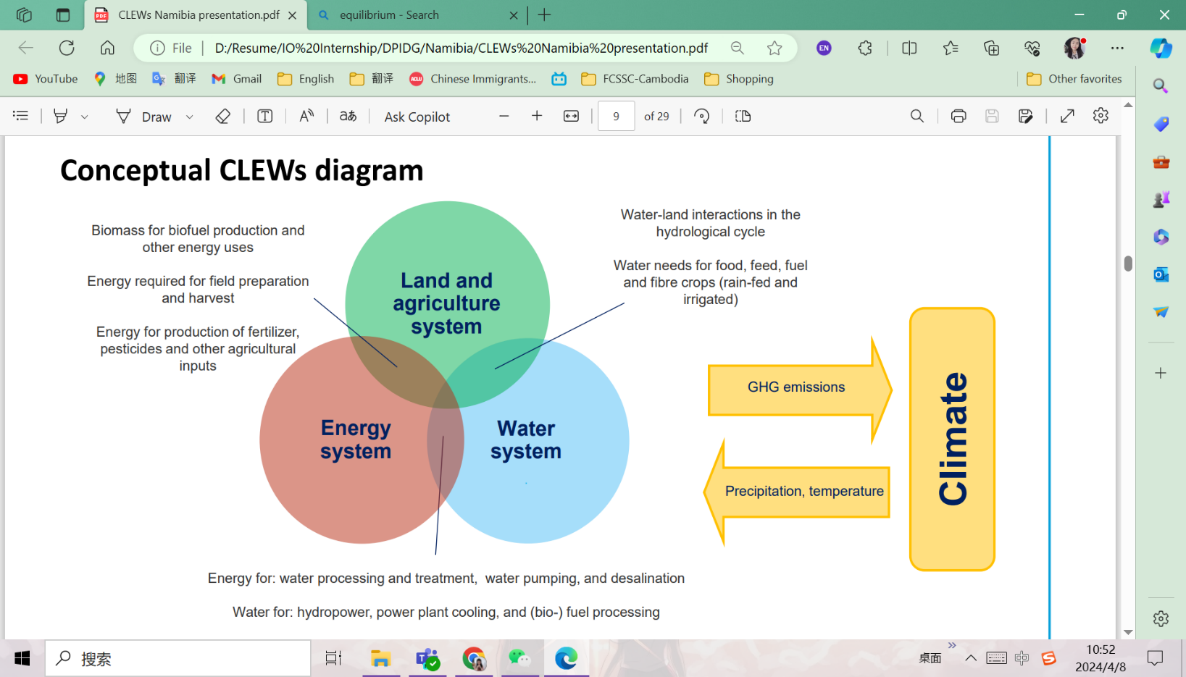

CLEWs can analyze policy decisions on issues such as energy supply and use, competition for water, GHG emission reductions, climate resilience, land-use change and agricultural modernization. The model is structured so that each component of the system (natural resource or human infrastructure) is described by its economic, technical, environmental and bio-physical characteristics. This is often referred to as a “bottom-up” approach. It allows the user to study the impact of choices made at the “bottom” level (i.e. decisions taken by governments, households, investors and businesses) and see how they affect the overall resource use, the environment and costs incurred. It allows for exploration of the impacts of technology choice and technological change.

CLEWs SETs:
The definitions of set memberships is completely flexible and the primary limitations are data availability and computation time. It should thus be possible to adjust detail and structure to facilitate interlinkages with OG.

set TECHNOLOGY; Each productive unit of the model that uses, produces or converts one or more commodities.
set COMMODITY; All flows (energy, volume, weight, land, etc.)
set EMISSION; Solid, liquid or gaseous emissions/waste products
set STORAGE; Infrastructure used of intertemporal storage/arbitrage of commodities
set YEAR; List of model years
set SEASON; List of seasons
set DAYTYPE; List of day-types (e.g. weekday vs weekend)
set DAILYTIMEBRACKET; (e.g. sub-divisions of a day e.g. corresponding to peak, intermediate and baseload electricity demand)
set TIMESLICE;
set MODE_OF_OPERATION; Allows for the use of the same piece of equipment/infrastructure to be used in different ways (e.g. running a power plant on oil instead of gas).
set UDC; Flexible constraints to enforce set relationships between variables.

Main CLEWs inputs:
- General time preference rate
- Hurdle rate for individual technologies
- Description of technical characteristics of individual technologies (Availability, conversion efficiency, operational life, existing capacities, etc)
- Cost structure for technologies (Capital cost, fixed O&M, Variable O&M)
- Time representation (years to include in analysis, subdivisions of year – seasons, day types, within day time steps)
- Exogenous demands for commodities (i.e. demands originating outside the modelled system)
- Emission factors
- Various constraints on the capacity, investment and utilization of technologies

Main CLEWs outputs:
- Capacity additions for each technology (in units of capacity – e.g. Gigawatt, Tons per day etc. )
- Total capacity for each technology (in units of capacity)
- Capital investment (in units of currency)
- Operating expenditures (in units of currency – to pay for labor and other inputs not directly modelled)
- Utilization level of all technologies
- Total inputs and outputs of commodity flows for each technology
- Total production/use of each technology
- Emissions by technology
- Salvage values

For more information about CLEWs Framework, see: How to advance the 2030 Agenda with the Climate, Land-Use, Energy and Water Systems Models (CLEWs) (youtube.com)

